[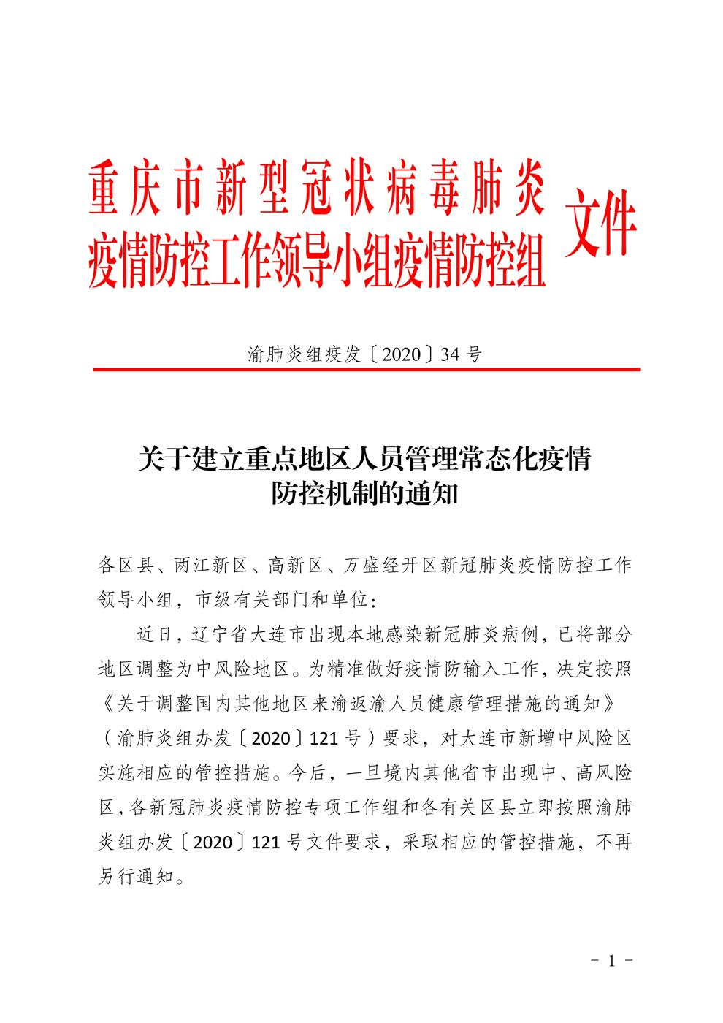](http://www.cqdkj.com/Media/Contentthemes/default/images/2020_7/771539d6796547648a5cc88c2ed417ed.jpg)

[](http://www.cqdkj.com/Media/Contentthemes/default/images/2020_7/ebc28d27b80c47f4a46dbc89743b7b0f.jpg)[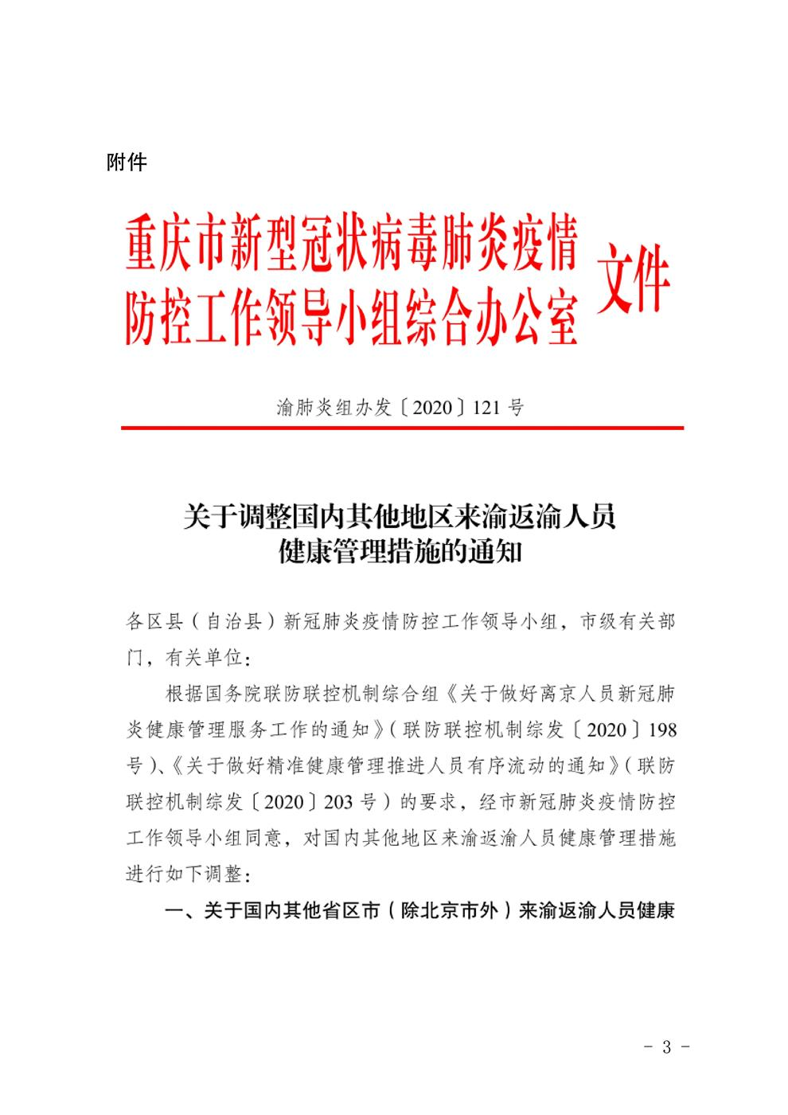](http://www.cqdkj.com/Media/Contentthemes/default/images/2020_7/4d870dbb5e3b48819d5b945efaf61096.jpg)[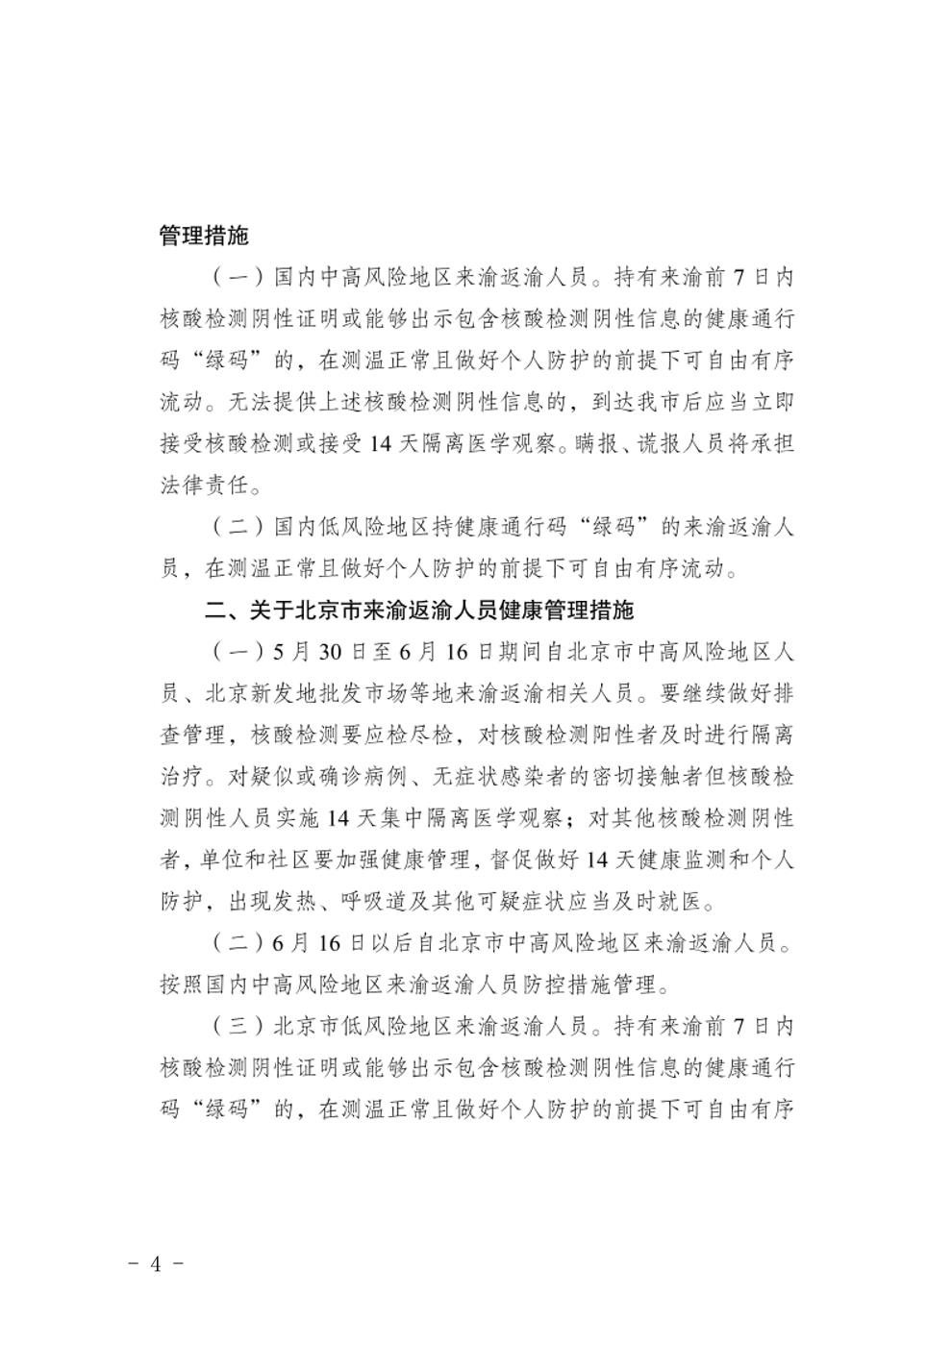](http://www.cqdkj.com/Media/Contentthemes/default/images/2020_7/3596ca1023644f6091004fc1c48586cd.jpg)[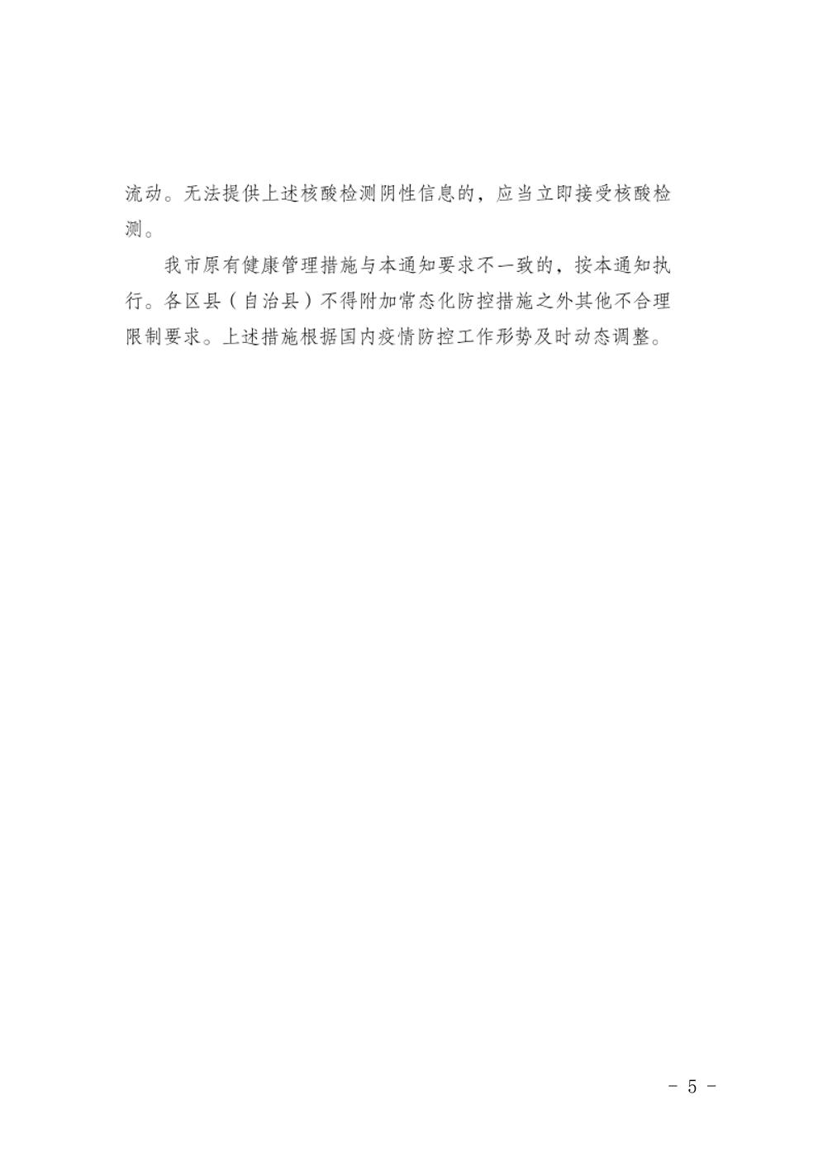](http://www.cqdkj.com/Media/Contentthemes/default/images/2020_7/463fb7c6fa694b8793e83cf2db67e3e0.jpg)[](http://www.cqdkj.com/Media/Contentthemes/default/images/2020_7/f0e8e295483048cd92f68d1986e82afc.jpg)